Quadrilateral Prism
# Source: AI Source: Provided by: [Data Path: Persons Table -> ID Column: 1, Name_En Column: Motasem Essam] -> From: [ChatGPT] on [7/25/2026]
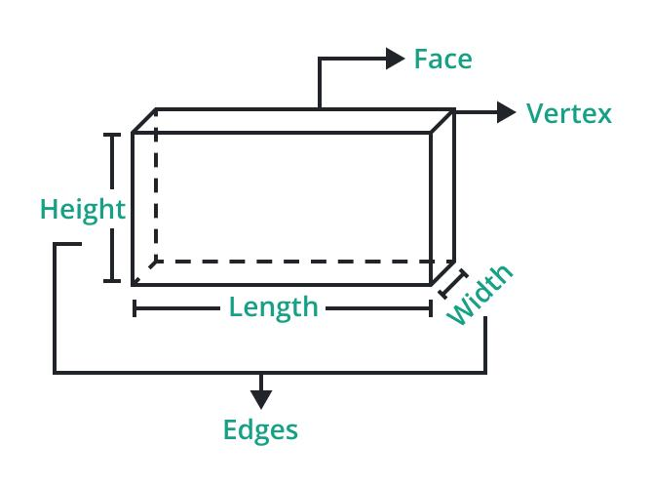
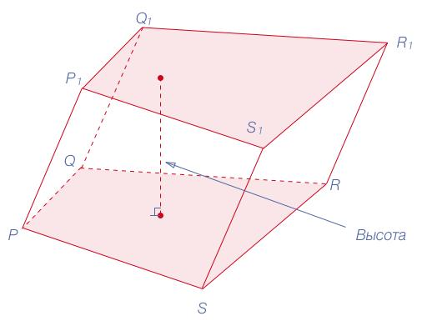
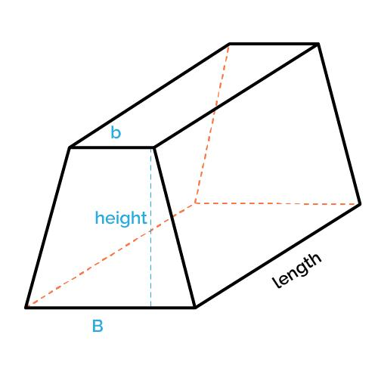

Definition
# Source: AI Source: Provided by: [Data Path: Persons Table -> ID Column: 1, Name_En Column: Motasem Essam] -> From: [ChatGPT] on [7/25/2026]
A quadrilateral prism is a three-dimensional geometric solid with two congruent, parallel quadrilateral bases connected by four lateral faces.
A quadrilateral is a polygon with four sides. Therefore, the shape of the two bases determines the particular type of quadrilateral prism.
For example, a prism with rectangular bases is a rectangular prism, while a prism with trapezoidal bases is a trapezoidal prism.
A quadrilateral prism has:
- 2 quadrilateral bases
- 4 lateral faces
- 6 faces in total
- 12 edges
- 8 vertices
In a right quadrilateral prism, the lateral edges are perpendicular to the bases, and the lateral faces are rectangles. In an oblique quadrilateral prism, the lateral edges are inclined to the bases, and the lateral faces are generally parallelograms.

Simple Definition
# Source: AI Source: Provided by: [Data Path: Persons Table -> ID Column: 1, Name_En Column: Motasem Essam] -> From: [ChatGPT] on [7/25/2026]
A quadrilateral prism is a solid shape with two identical, parallel four-sided bases joined by four side faces.
For example, a box-shaped solid with rectangular bases is a quadrilateral prism.

Classification Tree
# Source: AI Source: Provided by: [Data Path: Persons Table -> ID Column: 1, Name_En Column: Motasem Essam] -> From: [ChatGPT] on [7/25/2026]
Quadrilateral Prism
By lateral edges
Right quadrilateral prism
Oblique quadrilateral prism
By base shape
Rectangular-base prism
Square-base prism
Parallelogram-base prism
Trapezoidal-base prism
Other quadrilateral-base prisms
Important distinction: These classifications describe different properties. A prism can have a rectangular base and be right or oblique. A square-based right prism is a special case of a right quadrilateral prism.

Key Characteristics
# Source: AI Source: Provided by: [Data Path: Persons Table -> ID Column: 1, Name_En Column: Motasem Essam] -> From: [ChatGPT] on [7/25/2026]
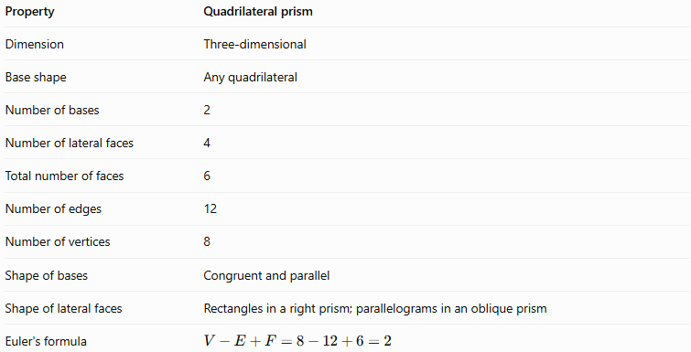
Property | Quadrilateral prism
Dimension | Three-dimensional
Base shape | Any quadrilateral
Number of bases | 2
Number of lateral faces | 4
Total number of faces | 6
Number of edges | 12
Number of vertices | 8
Shape of bases | Congruent and parallel
Shape of lateral faces | Rectangles in a right prism; parallelograms in an oblique prism
Euler's formula | $$V-E+F=8-12+6=2$$
The two bases have the same size and shape. Corresponding vertices are connected by four lateral edges.

Geometric Representation
# Source: AI Source: Provided by: [Data Path: Persons Table -> ID Column: 1, Name_En Column: Motasem Essam] -> From: [ChatGPT] on [7/25/2026]
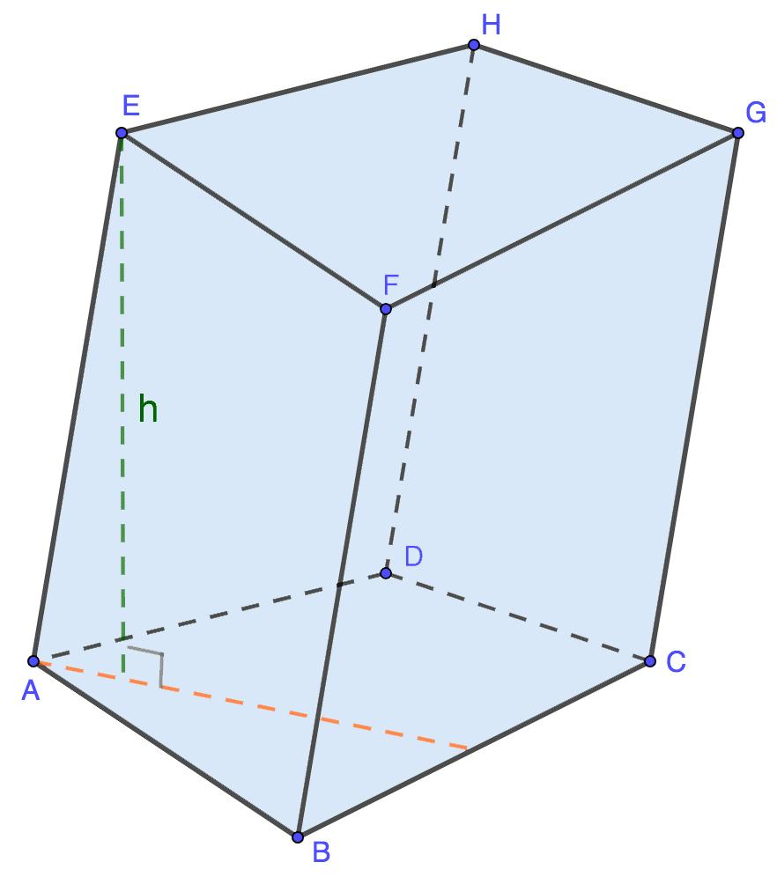
A quadrilateral prism can be labeled $ABCD-EFGH$, where:
- $ABCD$ is one quadrilateral base.
- $EFGH$ is the opposite, congruent base.
- $AE$, $BF$, $CG$, and $DH$ are the four lateral edges.
- The four lateral faces connect corresponding edges of the bases.
In a right prism, the lateral edges are perpendicular to the bases. In an oblique prism, they are inclined.

Types of Quadrilateral Prisms by Base Shape

1. Rectangular-Base Prism
# Source: AI Source: Provided by: [Data Path: Persons Table -> ID Column: 1, Name_En Column: Motasem Essam] -> From: [ChatGPT] on [7/25/2026]
A prism whose bases are rectangles. A right prism with rectangular bases is a rectangular prism, or cuboid, with six rectangular faces.
Example: A rectangular storage box.
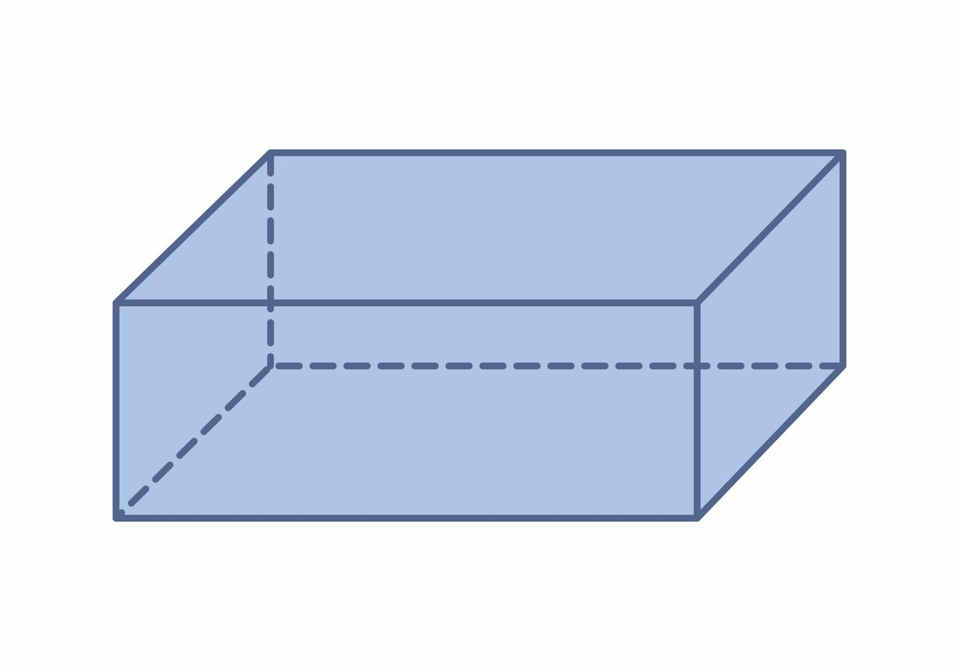

2. Square-Base Prism
# Source: AI Source: Provided by: [Data Path: Persons Table -> ID Column: 1, Name_En Column: Motasem Essam] -> From: [ChatGPT] on [7/25/2026]
A prism whose bases are squares. In a right square prism, the four lateral faces are rectangles. If its lateral edges equal the side length of the square bases, it is a cube.
Example: A cube-shaped storage container.
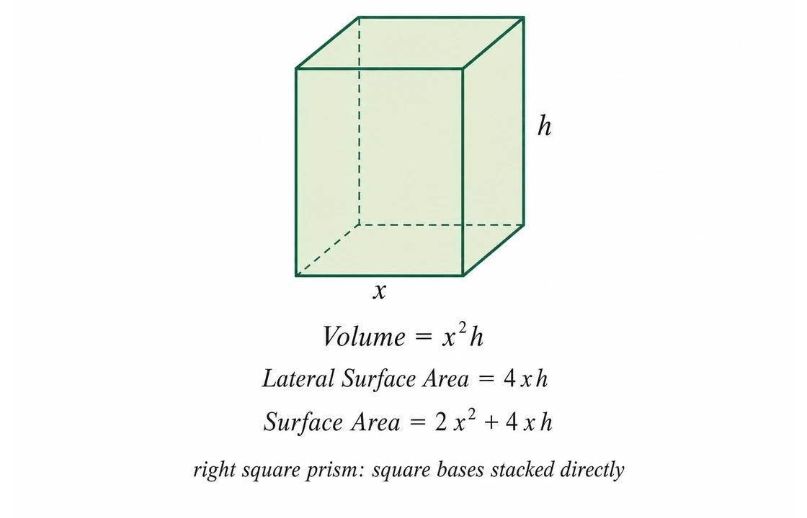

3. Parallelogram-Base Prism
# Source: AI Source: Provided by: [Data Path: Persons Table -> ID Column: 1, Name_En Column: Motasem Essam] -> From: [ChatGPT] on [7/25/2026]
A prism whose bases are parallelograms. A right prism of this type has rectangular lateral faces, while an oblique prism generally has parallelogram lateral faces.
Example: A solid with slanted parallelogram-shaped bases.
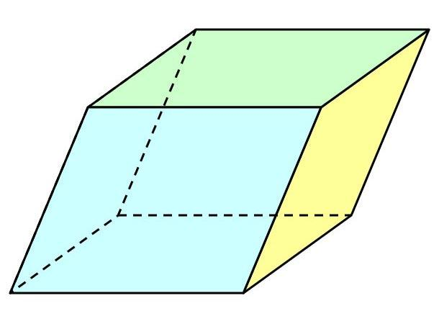

4. Trapezoidal-Base Prism
# Source: AI Source: Provided by: [Data Path: Persons Table -> ID Column: 1, Name_En Column: Motasem Essam] -> From: [ChatGPT] on [7/25/2026]
A prism whose bases are trapezoids. The trapezoidal bases are congruent and parallel, and four lateral faces connect them.
Example: A prism-shaped architectural component with trapezoidal ends.
Other quadrilateral shapes can also serve as the bases, including irregular quadrilaterals.

Types by Spatial Orientation

Right Quadrilateral Prism
# Source: AI Source: Provided by: [Data Path: Persons Table -> ID Column: 1, Name_En Column: Motasem Essam] -> From: [ChatGPT] on [7/25/2026]
The lateral edges are perpendicular to the base planes. Its lateral faces are rectangles.
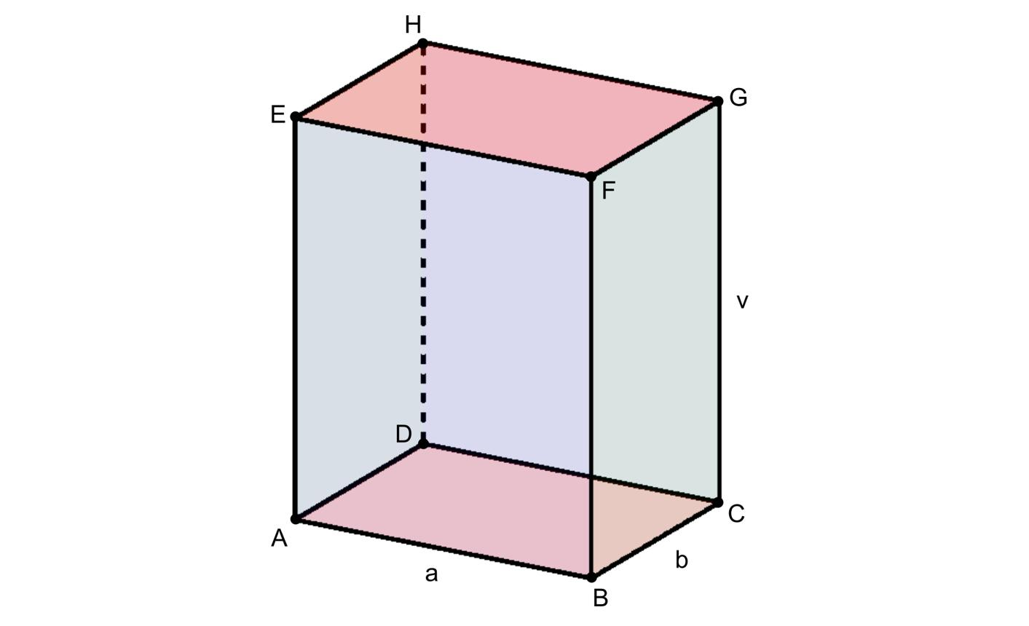

Oblique Quadrilateral Prism
# Source: AI Source: Provided by: [Data Path: Persons Table -> ID Column: 1, Name_En Column: Motasem Essam] -> From: [ChatGPT] on [7/25/2026]
The lateral edges are inclined to the base planes. Its lateral faces are parallelograms.
The distinction between right and oblique prisms depends on the angle of the lateral edges relative to the bases, not on whether the bases are squares, rectangles, or other quadrilaterals.
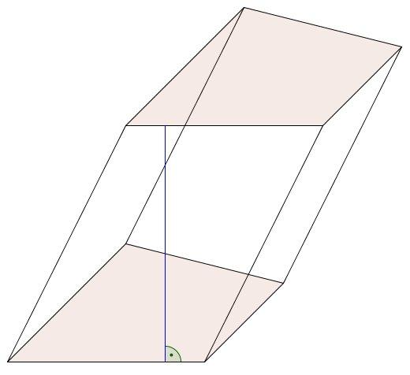

Mathematical Formulas
# Source: AI Source: Provided by: [Data Path: Persons Table -> ID Column: 1, Name_En Column: Motasem Essam] -> From: [ChatGPT] on [7/25/2026]
Let:
- $B$ = area of one quadrilateral base
- $p$ = perimeter of the base
- $h$ = perpendicular distance between the base planes
- $A_{L}$ = lateral surface area
- $A_{T}$ = total surface area
- $V$ = volume

A. Volume
# Source: AI Source: Provided by: [Data Path: Persons Table -> ID Column: 1, Name_En Column: Motasem Essam] -> From: [ChatGPT] on [7/25/2026]
For both right and oblique quadrilateral prisms:
$$\boxed{V=Bh}$$
The height $h$ is the perpendicular distance between the bases, not necessarily the length of a slanted lateral edge.

B. Lateral Surface Area
# Source: AI Source: Provided by: [Data Path: Persons Table -> ID Column: 1, Name_En Column: Motasem Essam] -> From: [ChatGPT] on [7/25/2026]
For a right quadrilateral prism:
$$\boxed{A_{L}=ph}$$
This works because each lateral face is a rectangle, and the sum of their areas equals the base perimeter multiplied by the prism height.
For an oblique quadrilateral prism, calculate the areas of its four parallelogram-shaped lateral faces and add them:
$$\boxed{A_{L}=A_{1}+A_{2}+A_{3}+A_{4}}$$
Here, $A_{1},A_{2},A_{3},A_{4}$ are the areas of the four lateral faces.

C. Total Surface Area
# Source: AI Source: Provided by: [Data Path: Persons Table -> ID Column: 1, Name_En Column: Motasem Essam] -> From: [ChatGPT] on [7/25/2026]
For either type of prism:
$$\boxed{A_{T}=2B+A_{L}}$$
The total surface area includes both bases and all four lateral faces.

D. Finding the Base Area
# Source: AI Source: Provided by: [Data Path: Persons Table -> ID Column: 1, Name_En Column: Motasem Essam] -> From: [ChatGPT] on [7/25/2026]
The base is a quadrilateral, so its area depends on its shape.
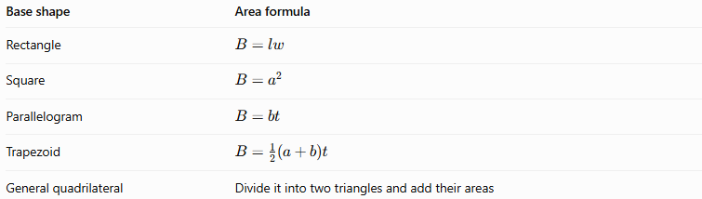
Base shape | Area formula
Rectangle | $$B=lw$$
Square | $$B=a^{2}$$
Parallelogram | $$B=bt$$
Trapezoid | $$B=\frac{1}{2}\left(a+b\right)t$$
General quadrilateral | Divide it into two triangles and add their areas
In these formulas, $l$ and $w$ are rectangle dimensions, $a$ is a square side, $b$ is a base length, and $t$ is the relevant perpendicular height. For a trapezoid, $a$ and $b$ are the parallel side lengths.

Worked Examples
# Source: AI Source: Provided by: [Data Path: Persons Table -> ID Column: 1, Name_En Column: Motasem Essam] -> From: [ChatGPT] on [7/25/2026]
Example 1: Counting Faces, Edges, and Vertices
A quadrilateral prism has a quadrilateral base. Determine its number of faces, edges, and vertices.
For an $n$-sided prism:
$$F=n+2, E=3n, V=2n$$
Since a quadrilateral has $n=4$ sides:
$$F=4+2=6$$
$$E=3\left(4\right)=12$$
$$V=2\left(4\right)=8$$
Answer: 6 faces, 12 edges, and 8 vertices.
Euler's formula confirms the result:
$$V-E+F=8-12+6=2$$
Example 2: Finding the Volume of a Right Rectangular-Base Prism
A right quadrilateral prism has a rectangular base measuring $8\text{ cm}$ by $5\text{ cm}$, and its perpendicular height is $12\text{ cm}$. Find its volume.
Step 1: Calculate the base area.
$$B=lw=8×5=40{\text{ cm}}^{2}$$
Step 2: Apply the volume formula.
$$V=Bh=40×12$$
$$\boxed{V=480{\text{ cm}}^{3}}$$
Example 3: Finding the Surface Area
A right quadrilateral prism has a rectangular base measuring $6\text{ cm}$ by $4\text{ cm}$, and a height of $10\text{ cm}$. Find its total surface area.
Step 1: Calculate the base area.
$$B=6×4=24{\text{ cm}}^{2}$$
Step 2: Calculate the base perimeter.
$$p=2\left(6+4\right)=20\text{ cm}$$
Step 3: Calculate the lateral surface area.
$$A_{L}=ph=20×10=200{\text{ cm}}^{2}$$
Step 4: Calculate the total surface area.
$$A_{T}=2B+A_{L}$$
$$A_{T}=2\left(24\right)+200$$
$$\boxed{A_{T}=248{\text{ cm}}^{2}}$$
Example 4: Finding the Height from the Volume
A quadrilateral prism has a base area of $35{\text{ cm}}^{2}$ and a volume of $420{\text{ cm}}^{3}$. Find its perpendicular height.
Starting with:
$$V=Bh$$
Rearrange to obtain:
$$h=\frac{V}{B}$$
Substitute the values:
$$h=\frac{420}{35}$$
$$\boxed{h=12\text{ cm}}$$

Comparison with Related Solids
# Source: AI Source: Provided by: [Data Path: Persons Table -> ID Column: 1, Name_En Column: Motasem Essam] -> From: [ChatGPT] on [7/25/2026]
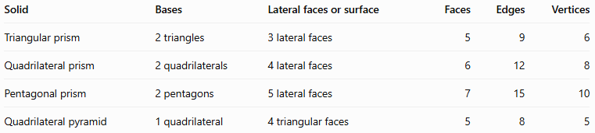
Solid | Bases | Lateral faces or surface | Faces | Edges | Vertices
Triangular prism | 2 triangles | 3 lateral faces | 5 | 9 | 6
Quadrilateral prism | 2 quadrilaterals | 4 lateral faces | 6 | 12 | 8
Pentagonal prism | 2 pentagons | 5 lateral faces | 7 | 15 | 10
Quadrilateral pyramid | 1 quadrilateral | 4 triangular faces | 5 | 8 | 5
A quadrilateral prism differs from a quadrilateral pyramid because the prism has two congruent, parallel bases, whereas the pyramid has one base and triangular lateral faces that meet at a single apex.

Real-World Applications
# Source: AI Source: Provided by: [Data Path: Persons Table -> ID Column: 1, Name_En Column: Motasem Essam] -> From: [ChatGPT] on [7/25/2026]
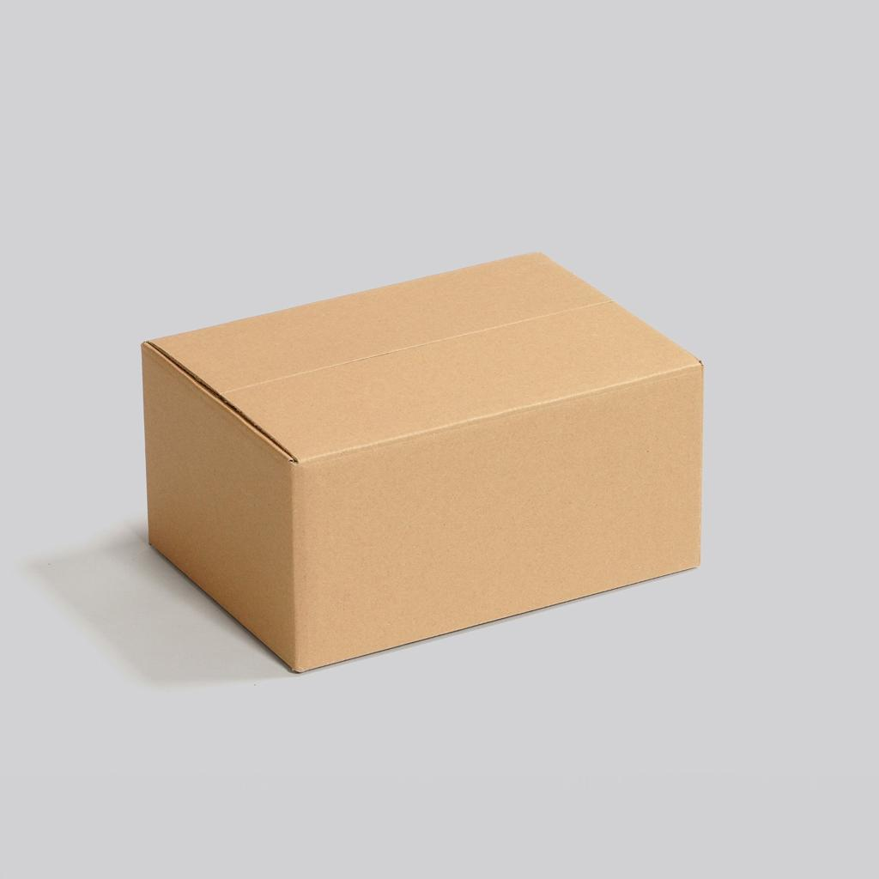
Packaging and storage
Boxes, cartons, and storage containers often have the shape of a rectangular prism.

Architecture and construction
Prism-shaped components can be used in structural designs, roof elements, and building materials.
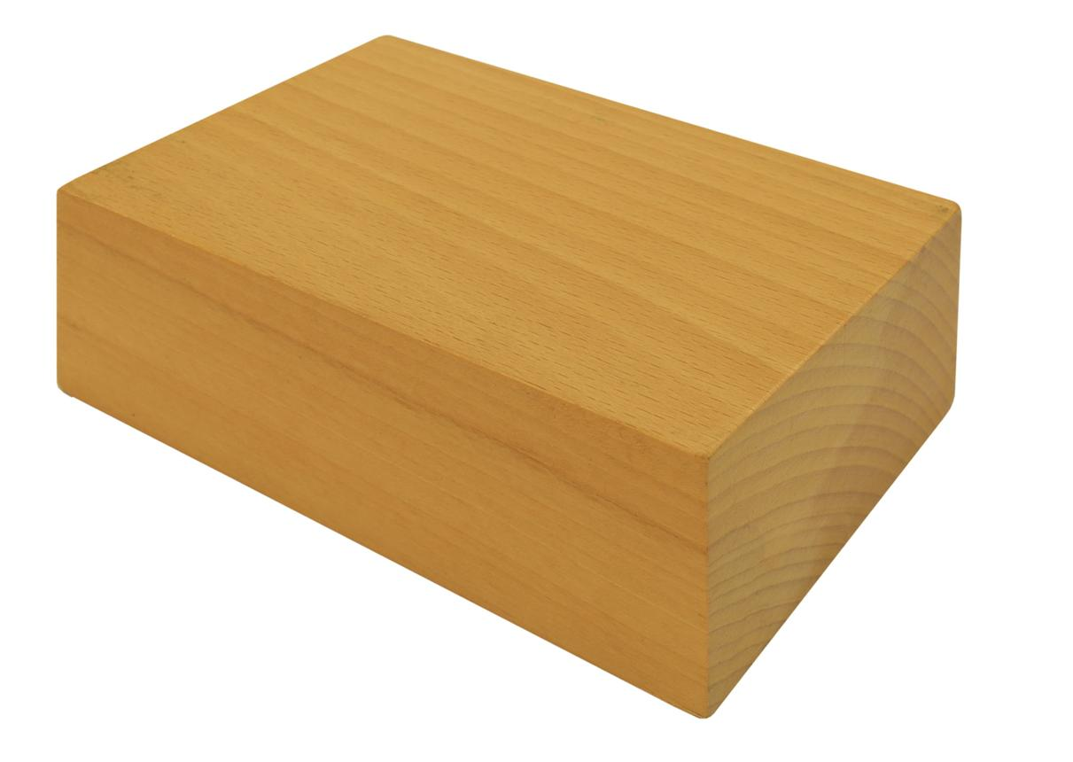
Manufacturing and engineering
Bars, blocks, and machined components can be modeled using prism geometry to calculate dimensions, volume, and surface area.

Key Points
# Source: AI Source: Provided by: [Data Path: Persons Table -> ID Column: 1, Name_En Column: Motasem Essam] -> From: [ChatGPT] on [7/25/2026]
- A quadrilateral prism has two congruent, parallel quadrilateral bases.
- It has 6 faces, 12 edges, and 8 vertices.
- Its base can be a square, rectangle, parallelogram, trapezoid, or another quadrilateral.
- A right prism has rectangular lateral faces; an oblique prism generally has parallelogram lateral faces.
- The volume is $V=Bh$, using the perpendicular distance between the bases.
- The total surface area is $A_{T}=2B+A_{L}$.
- It satisfies Euler's formula: $V-E+F=2$.

Conclusion
# Source: AI Source: Provided by: [Data Path: Persons Table -> ID Column: 1, Name_En Column: Motasem Essam] -> From: [ChatGPT] on [7/25/2026]
A quadrilateral prism is a prism whose bases are four-sided polygons. Its defining structure consists of two congruent, parallel quadrilateral bases joined by four lateral faces. Understanding its base shape, orientation, faces, edges, and vertices makes it possible to classify the solid and calculate its volume and surface area.

